**E Commerce Website Project**

**Source Code**

<https://github.com/yashsharmaembark/Yash-Sharma_E-Commerce-Website-Project_HDFC-JFS-B1-29th-July-2022>

**What the Website does**

This Website is a E Commerce Website. This Website has Products like Marvel's Spiderman Miles Morales Ultimate Edition (PS5), Apple MacBook Pro(8GB RAM, 256GB SSD, 33.78cm, Space Grey), Trigger Unisex Shoes Puma Black | Everything Black, OnePlus 9 Pro 256 GB, 12 GB RAM, Pine Green, Smartphone, Van Heusen Beige Jeans For Male, Van Heusen Yellow T Shirt Men Polo, Black Printed Ready to Wear Lahenga with Blouse | Ye Manly nhi h yaar, Canon EOS 5D Mark IV DSLR Camera with 24-105mm f/4L II Lens.

**Introduction**

This E Commerce Website is a website where there are products like Laptop, Mobile Phone, Clothes, Camera etc.

This E Commerce Website has Home Page, Contact Page, Login with your account and Register your account Page, Product Details Page

**Login with your account**

In the below screenshot, we have Email field and Password field.

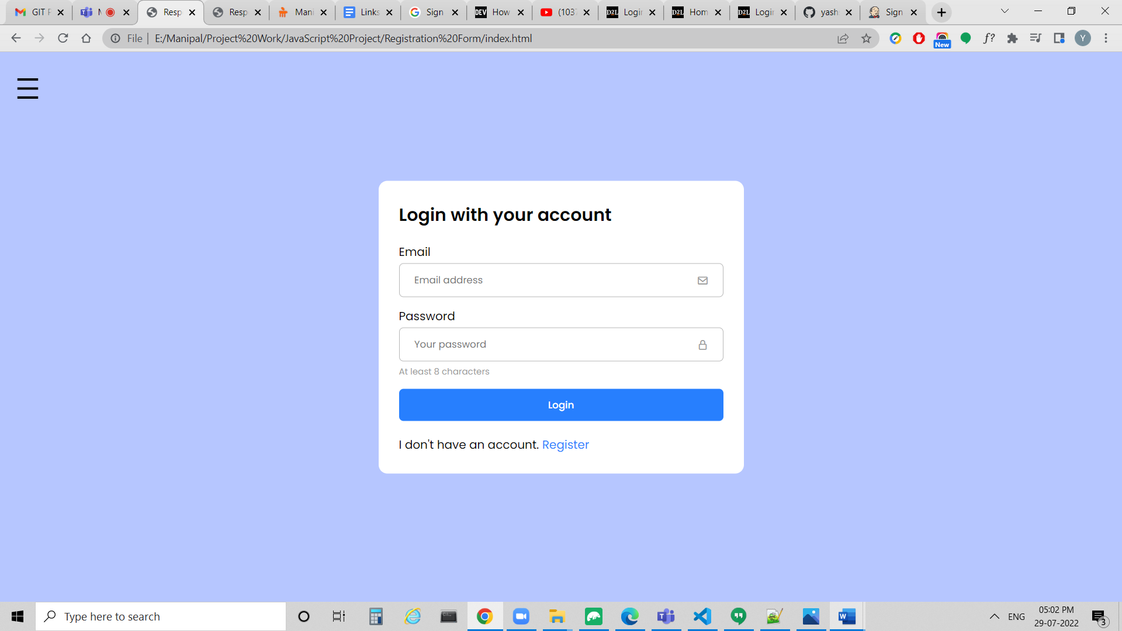

**Validation in Login with your account**

We have Validation for Email and Password.

**Email Validation**

In the below screenshot, this Message is given: Please include an ‘@’ in the email address. ‘yash’ is missing an ‘@’.

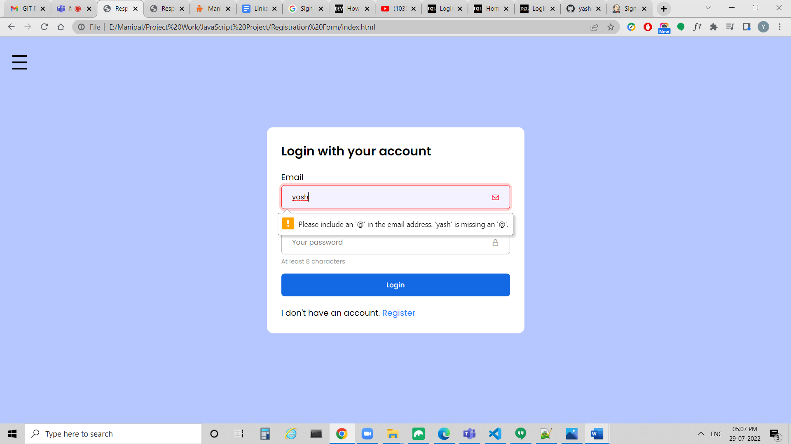

In the below screenshot, this Message is given: Please enter a part following ‘@’. ‘yash@’ is incomplete.

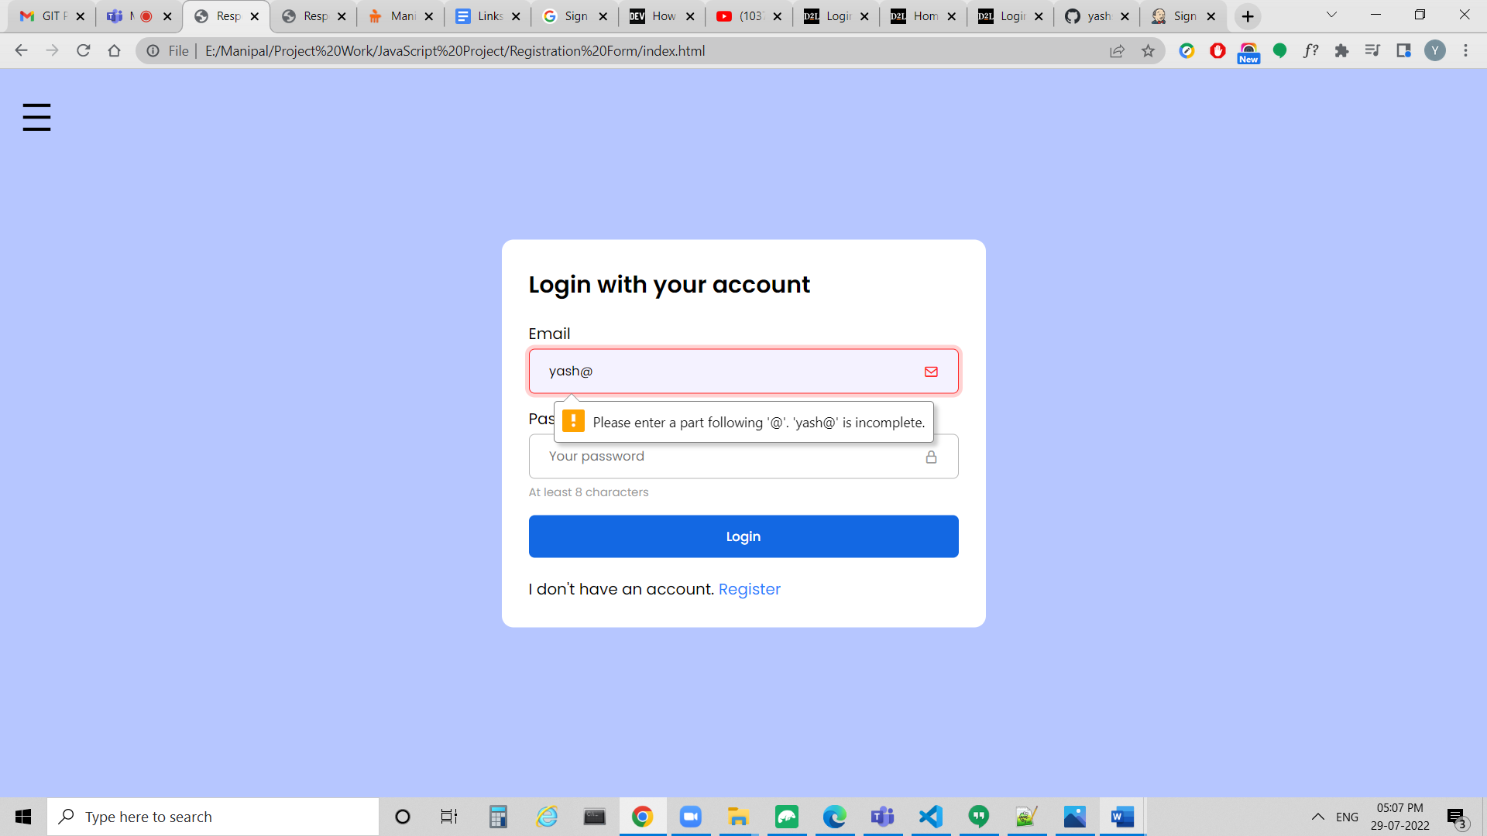

**Password Validation**

The Password should be At least 8 characters long.

In below screenshot, we have given Password of less than 8 characters, so Password field is highlighted in red color.

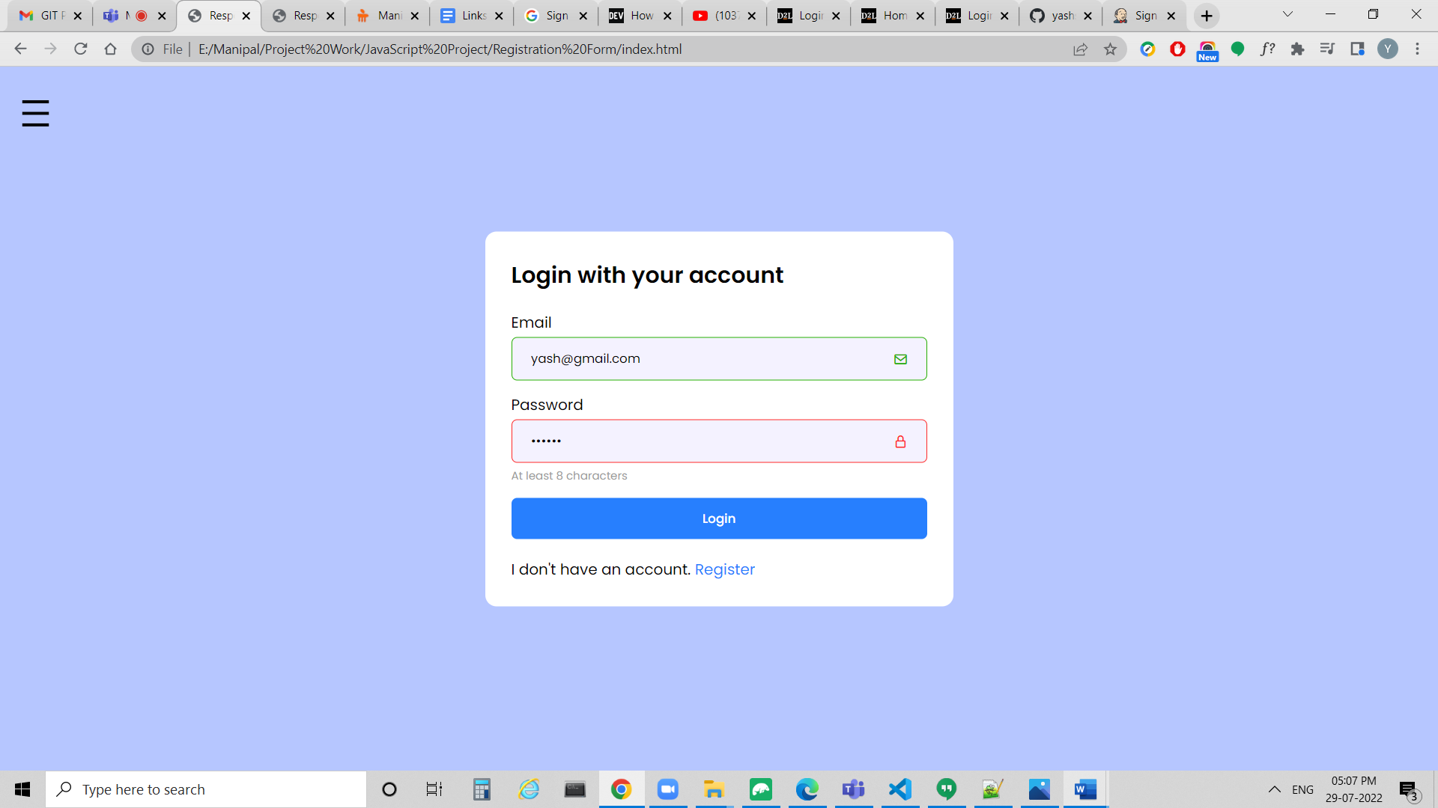

In the below screenshot, We have given the Email and Password in the correct format, so the Email and Password are highlighted in green color.

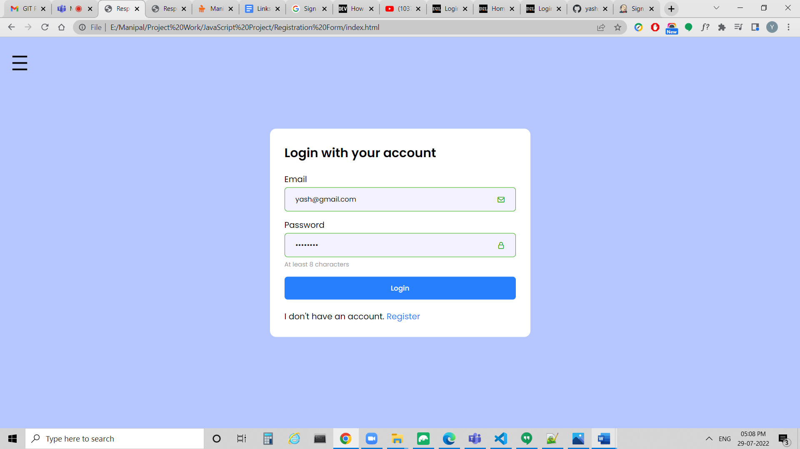

**Register your account**

We have Email, Password, Confirm password fields.

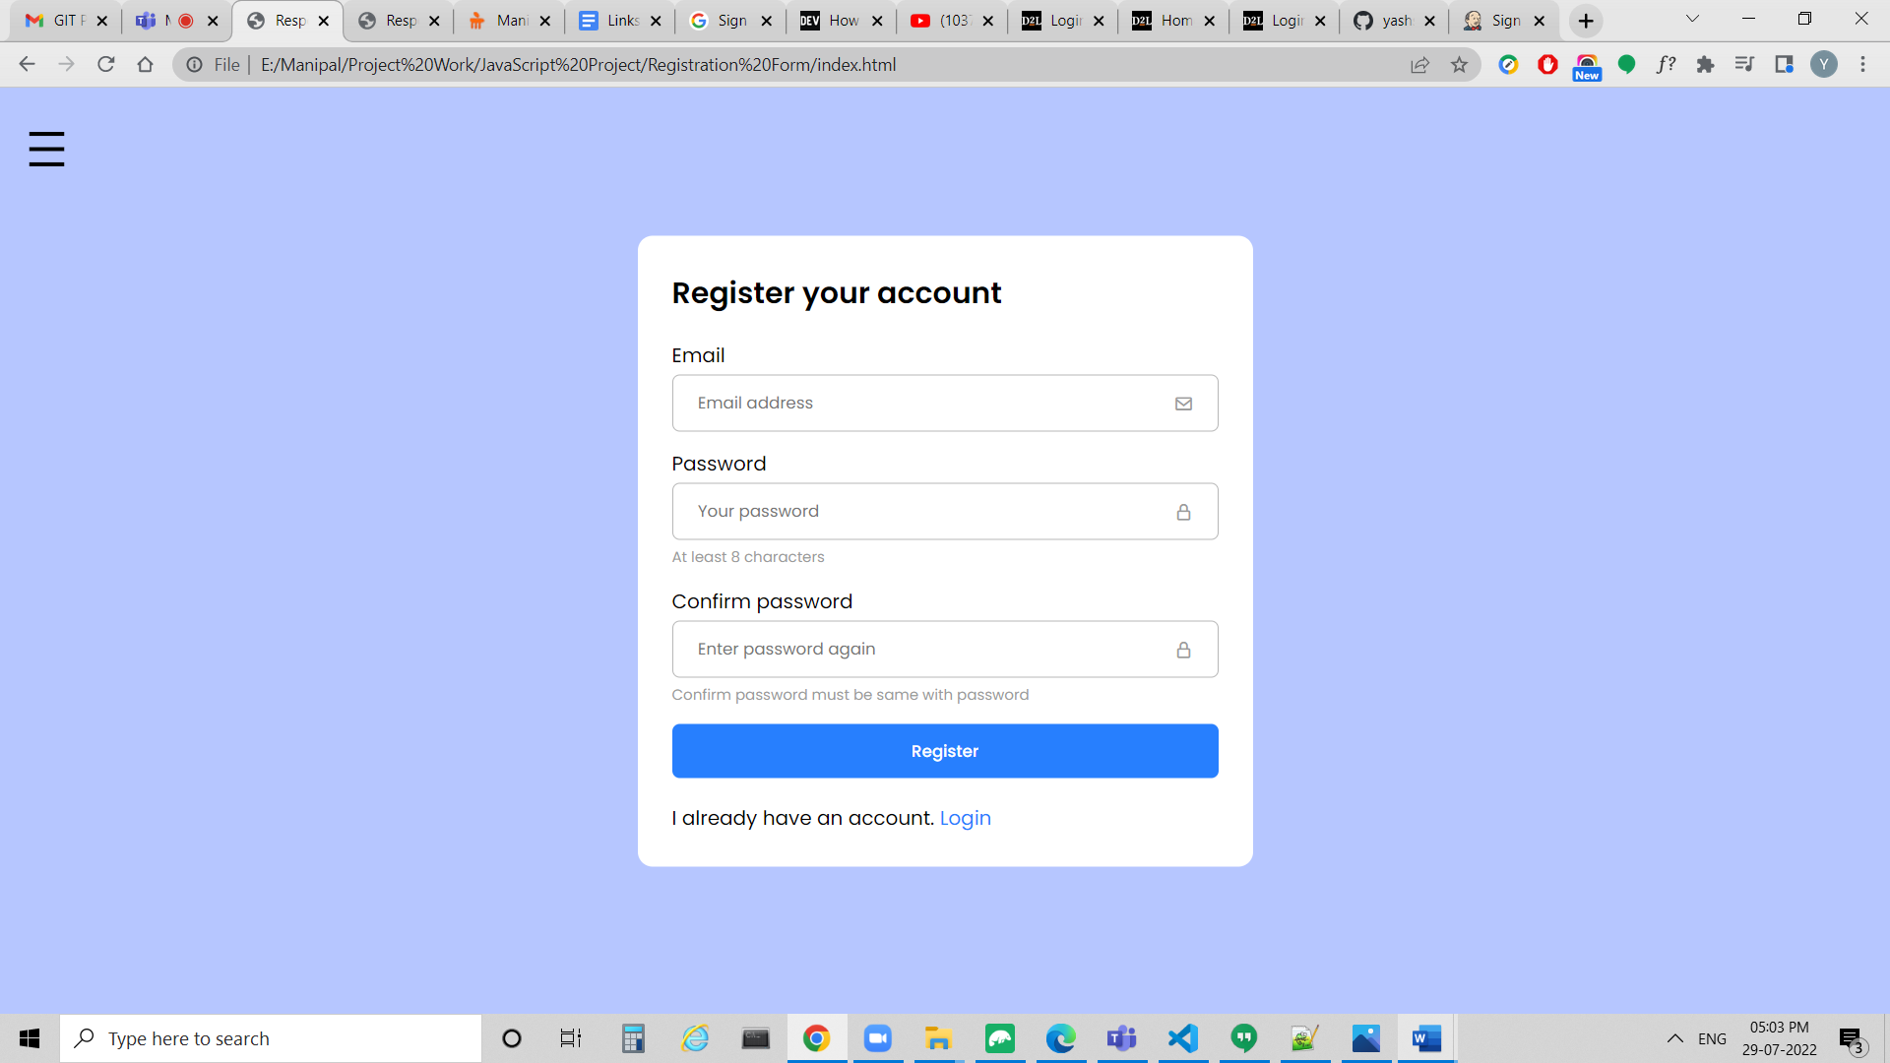

**Validation in Register your account**

We have Validation for Email, Password, Confirm password.

**Email Validation**

In the below screenshot, this Message is given: Please include an ‘@’ in the email address. ‘yash’ is missing an ‘@’.

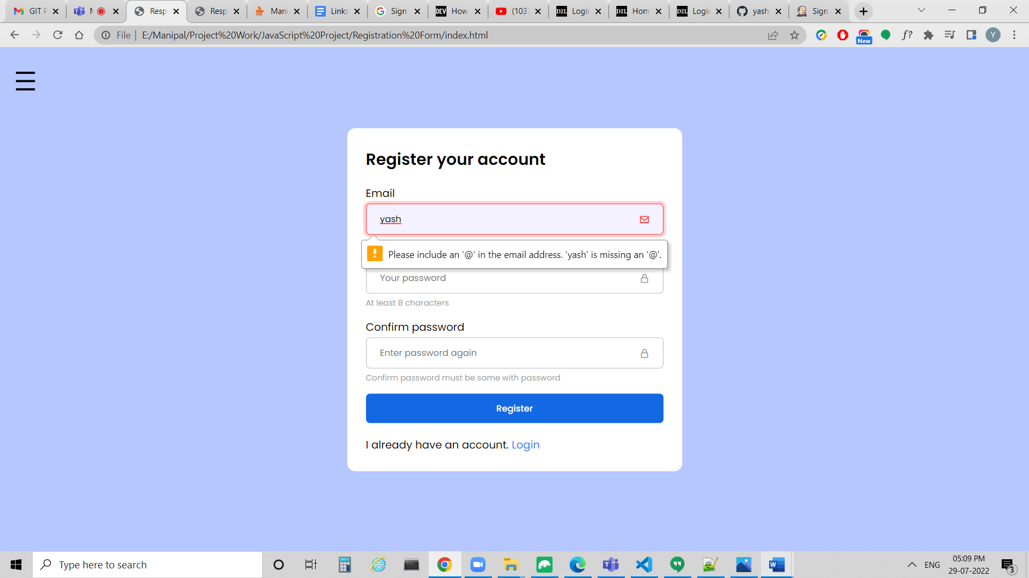

In the below screenshot, this Message is given: Please enter a part following ‘@’. ‘yash@’ is incomplete.

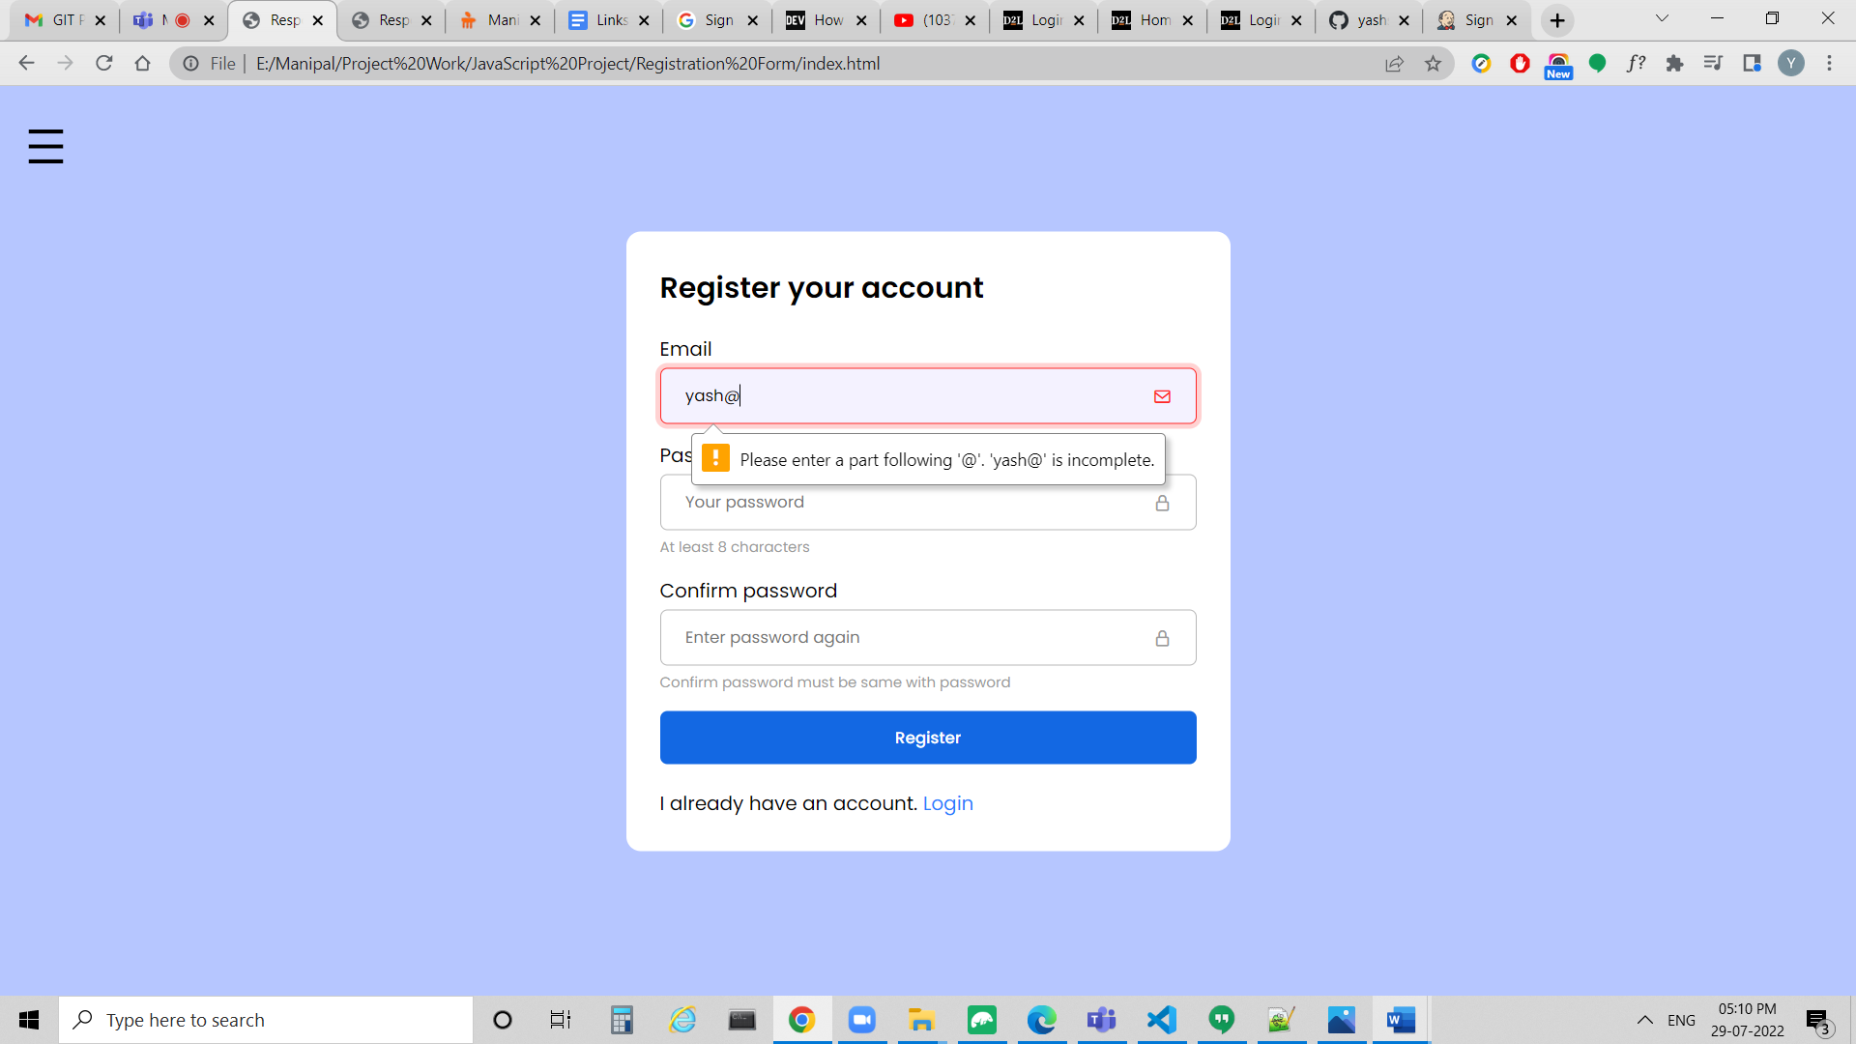

**Password Validation**

The Password should be At least 8 characters long.

In below screenshot, we have given Password of less than 8 characters, so Password field is highlighted in red color.

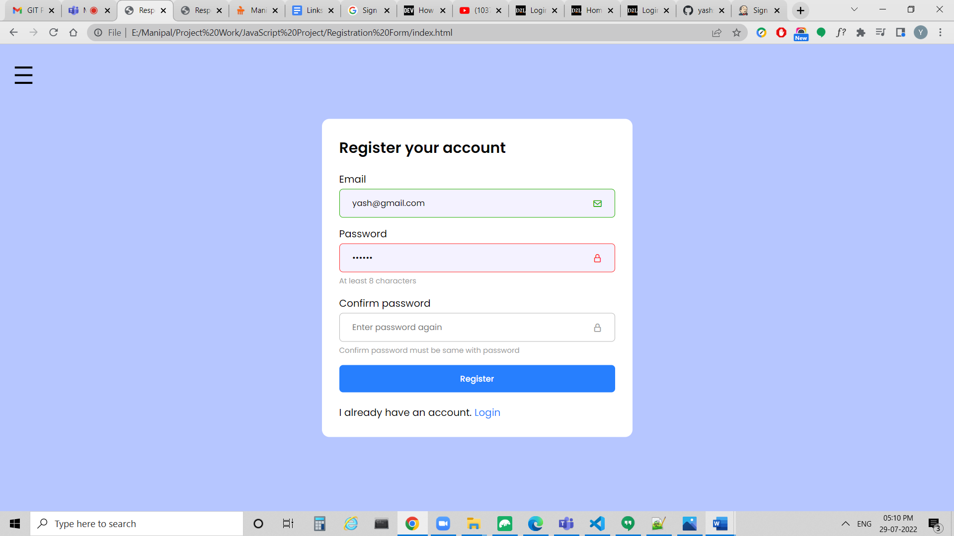

In Confirm password field, the password should be same as the Password entered in the Password field.

In the below screenshot, In Confirm password field, we have entered Password which is not same as the Password entered in the Password field, so the Confirm password field gets highlighted in red color.

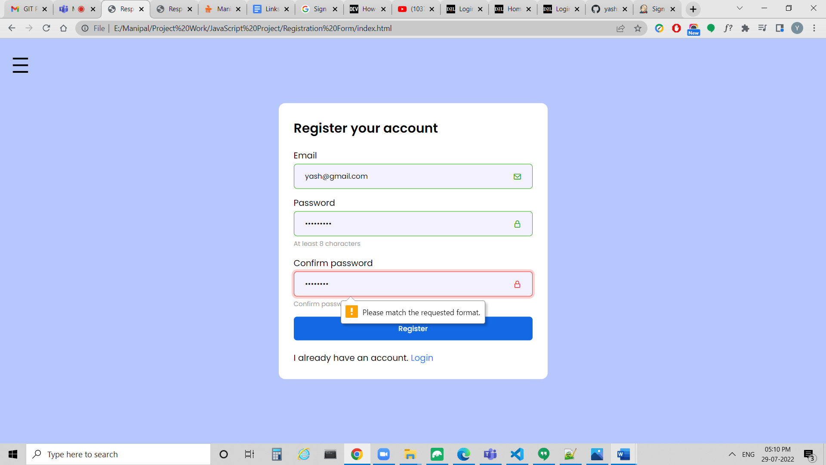

In the below screenshot, We have given the Email and Password in the correct format, so the Email and Password are highlighted in green color. We have given the same Password in Confirm password field as the Password given in Password field so the Confirm password field is also highlighted in green color.

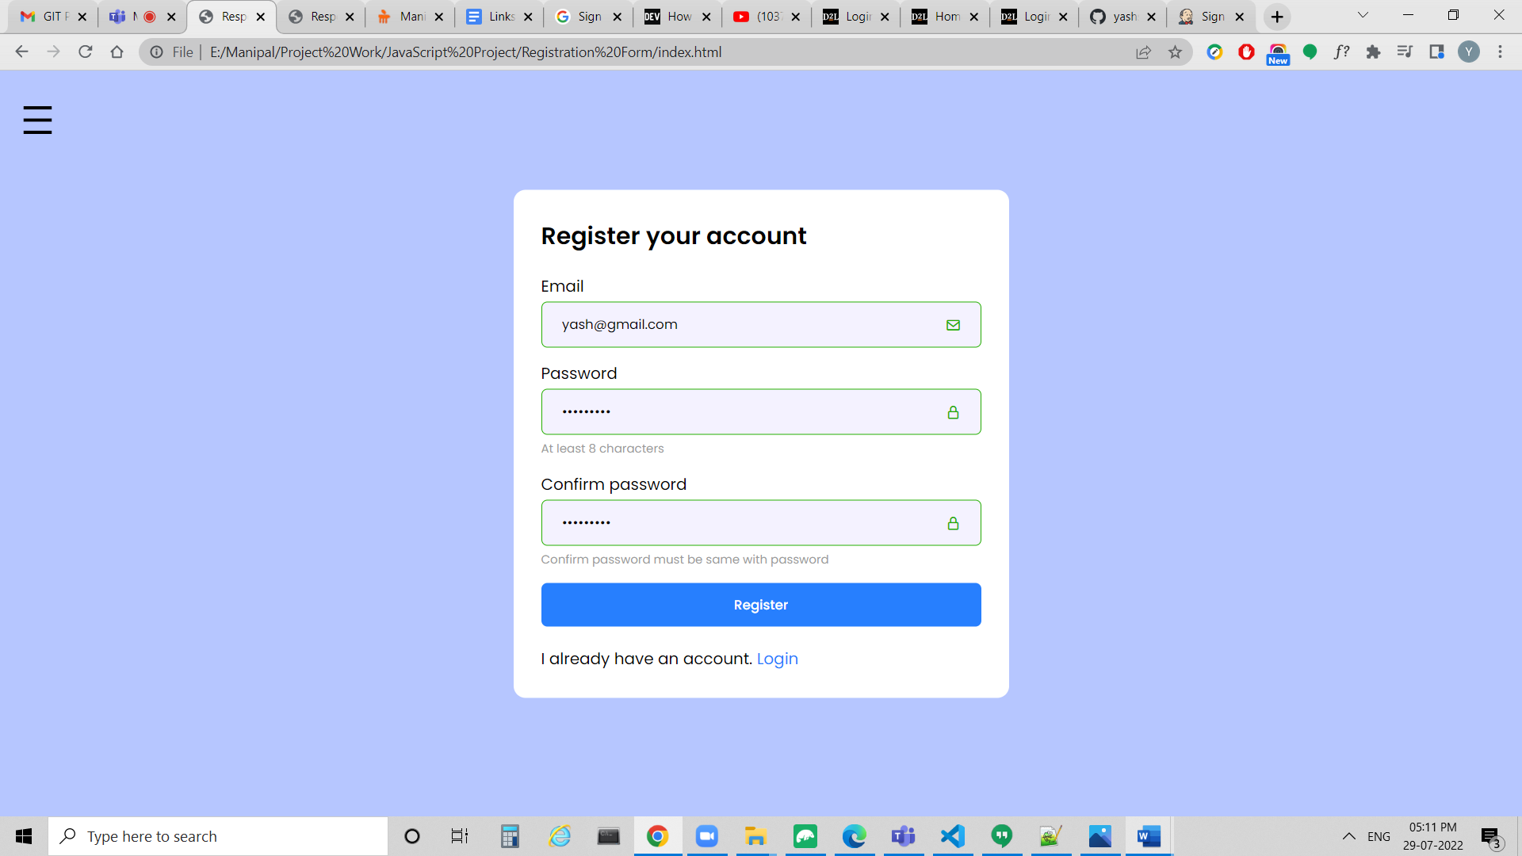

**Home Page**

In Home Page, we have Banner Image, Featured Products Section, Footer.

**Banner**

We have Laptop Image in Banner.

We have Scroll Button on the top of the Banner. If we hover on the Scroll Button, then the Background of the Scroll Button becomes transparent. If we click on the Scroll Button, we will go to Featured Products Section on the Home Page.

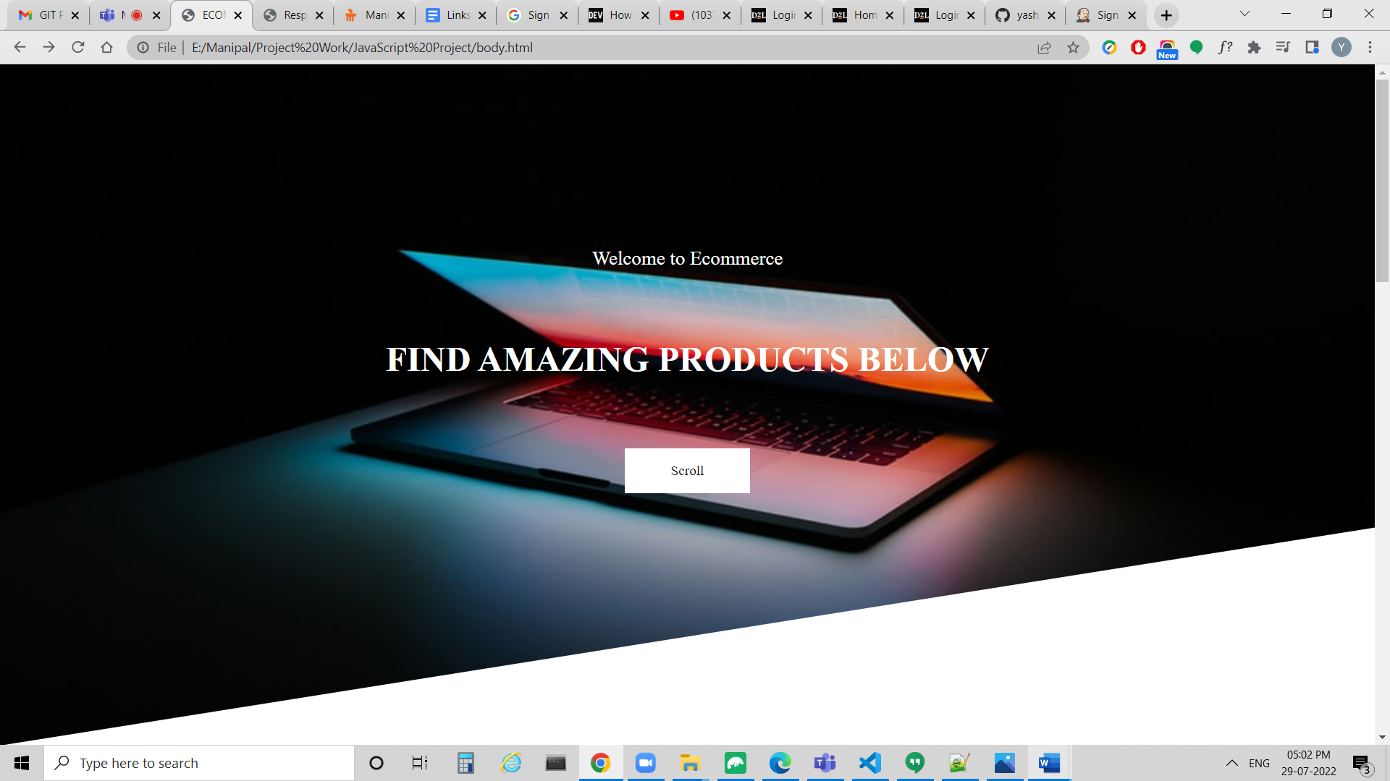

**Featured Products**

In Featured Products, we have Products like Marvel's Spiderman Miles Morales Ultimate Edition (PS5), Apple MacBook Pro(8GB RAM, 256GB SSD, 33.78cm, Space Grey), Trigger Unisex Shoes Puma Black | Everything Black, OnePlus 9 Pro 256 GB, 12 GB RAM, Pine Green, Smartphone, Van Heusen Beige Jeans For Male, Van Heusen Yellow T Shirt Men Polo, Black Printed Ready to Wear Lahenga with Blouse | Ye Manly nhi h yaar, Canon EOS 5D Mark IV DSLR Camera with 24-105mm f/4L II Lens.

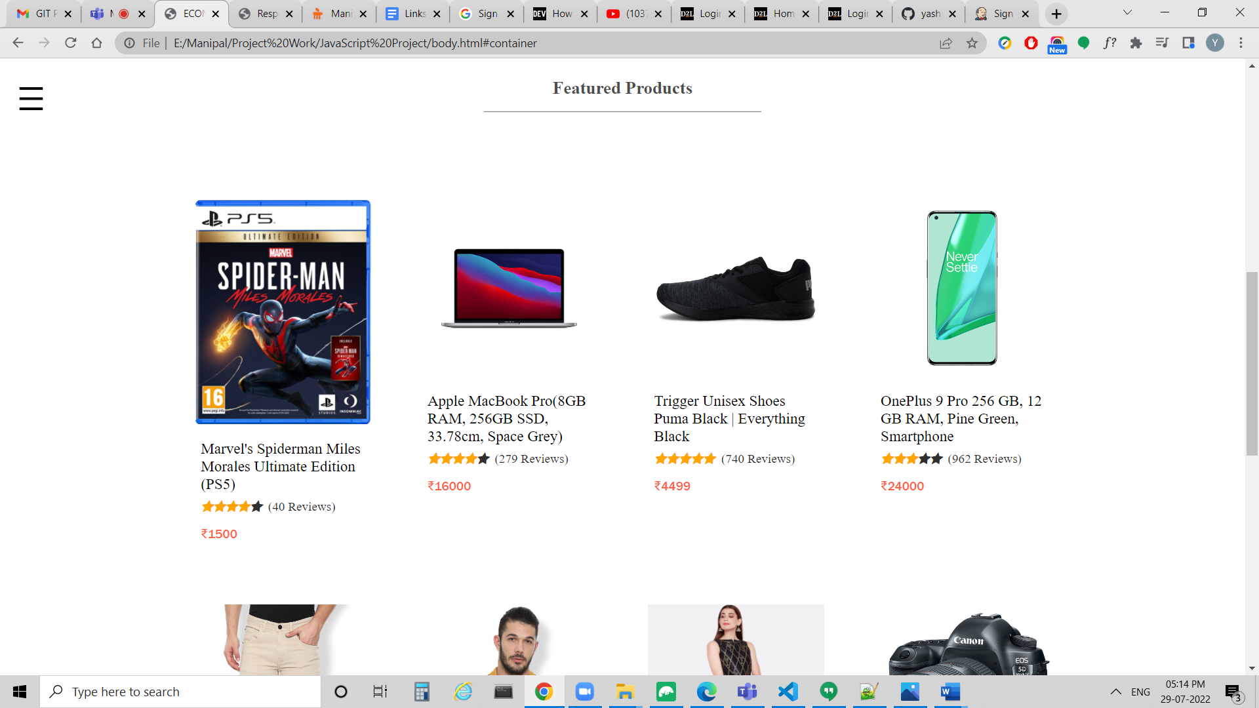

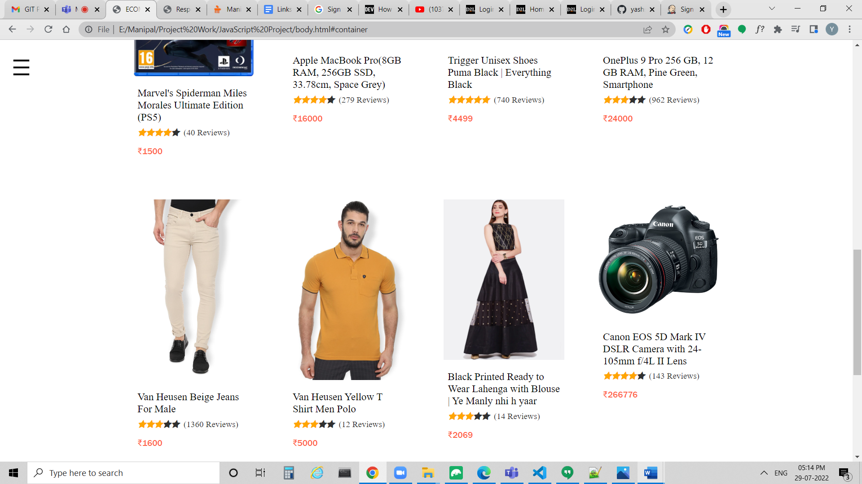

**Footer**

In Footer, we have Google Play Image and App Store Image.

We have Copyright.

We have Links for Instagram, Youtube, Facebook.

If we hover on Links for Instagram, Youtube, Facebook, the color will be changed to #eb4034.

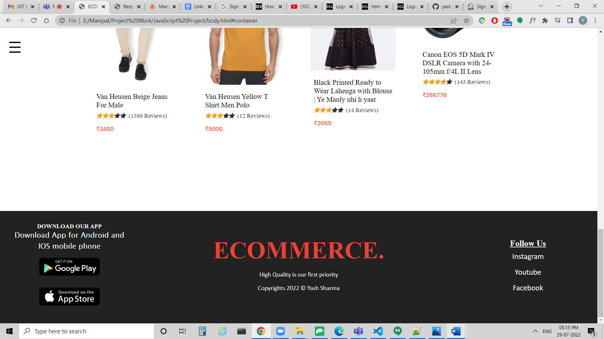

**Overlay Navbar**

In Overlay Navbar, We have ECOMMERCE Logo, Home, Contact, Icon to go to Login with your account and Register your account Page.

If we click on ECOMMERCE Logo, then we will get redirected to Home Page.

If we click on Home Menu Item, then we will get redirected to Home Page.

If we click on Contact Page, We will get redirected to Contact Page.

If we click on Icon to go to Login with your account and Register your account Page, then we will get redirected to Login with your account and Register your account Page.

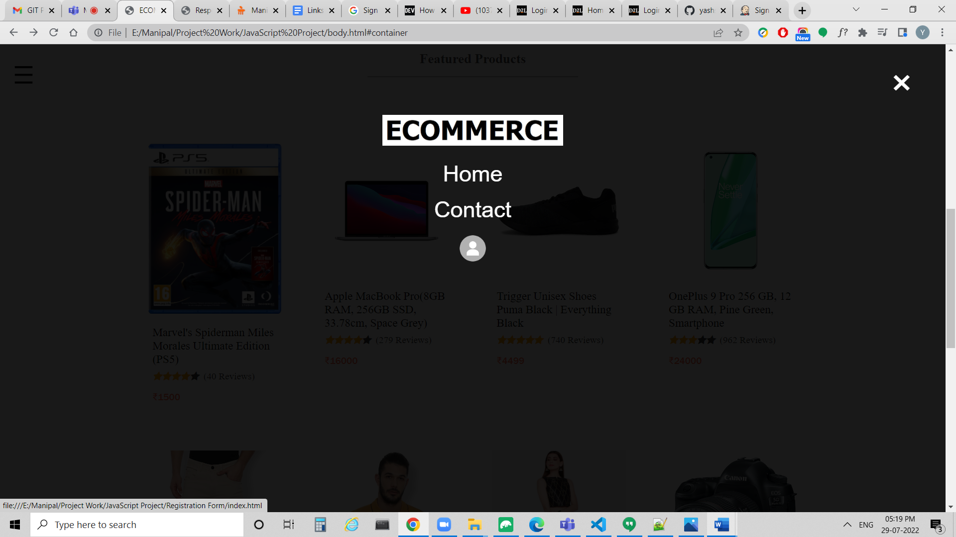

**Product Details Page**

In Product Details Page, We can find the details of Individual Products like Product Images, Product Title, Product Number, Ratings, Reviews, Price, Number of Items to be added to Cart, Add to Cart Button, Status, Description.

Below is the Screenshot of Marvel's Spiderman Miles Morales Ultimate Edition (PS5)

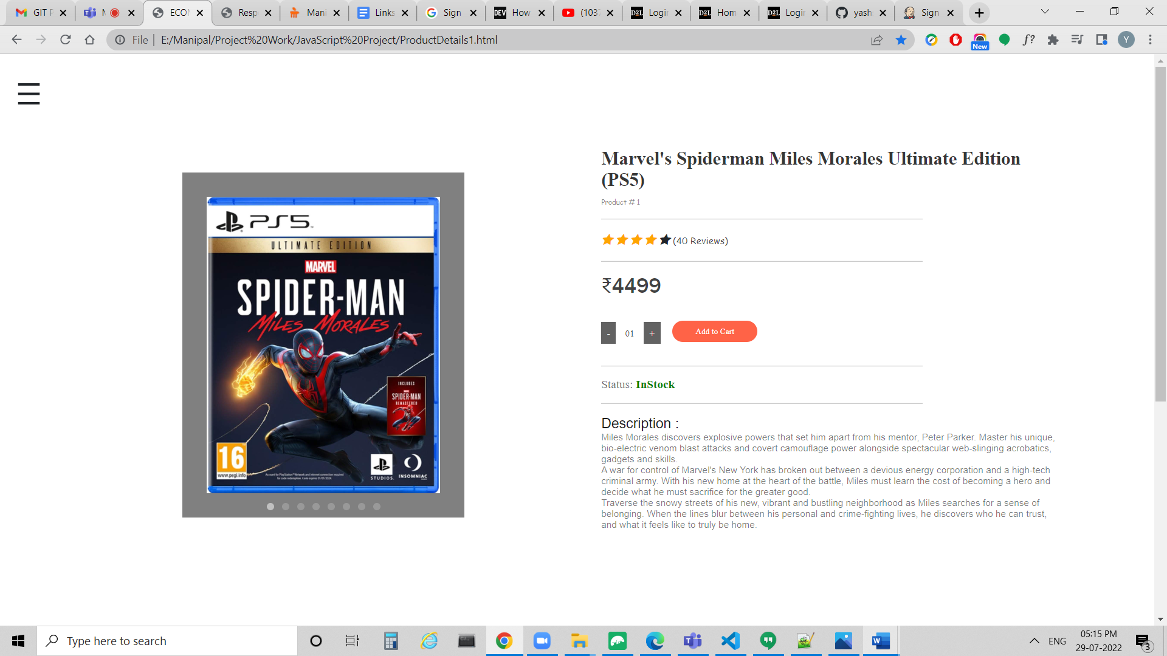

In Product Details Page, We have Product Images in Carousel.

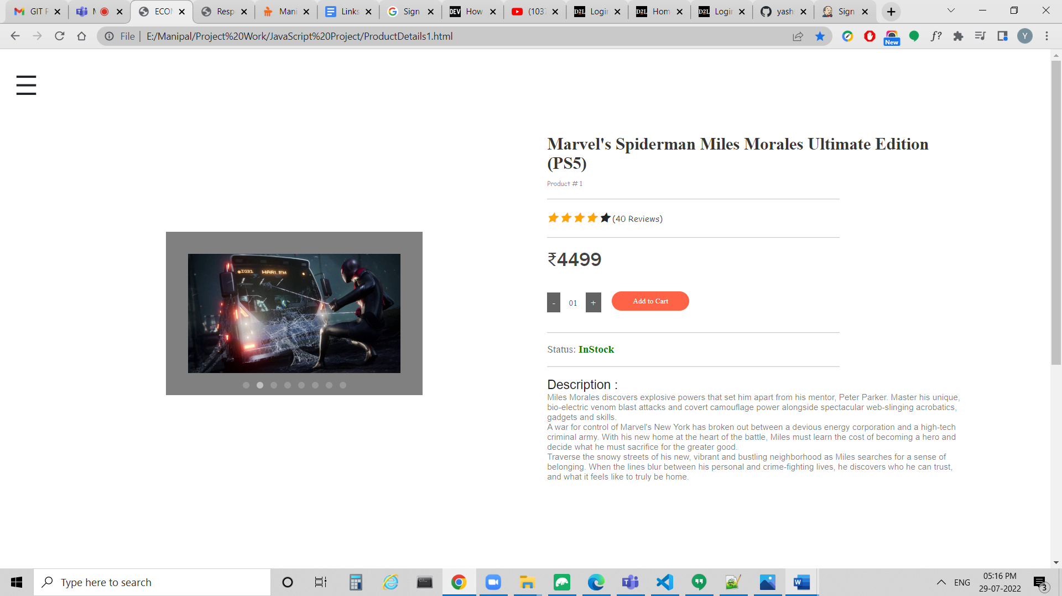

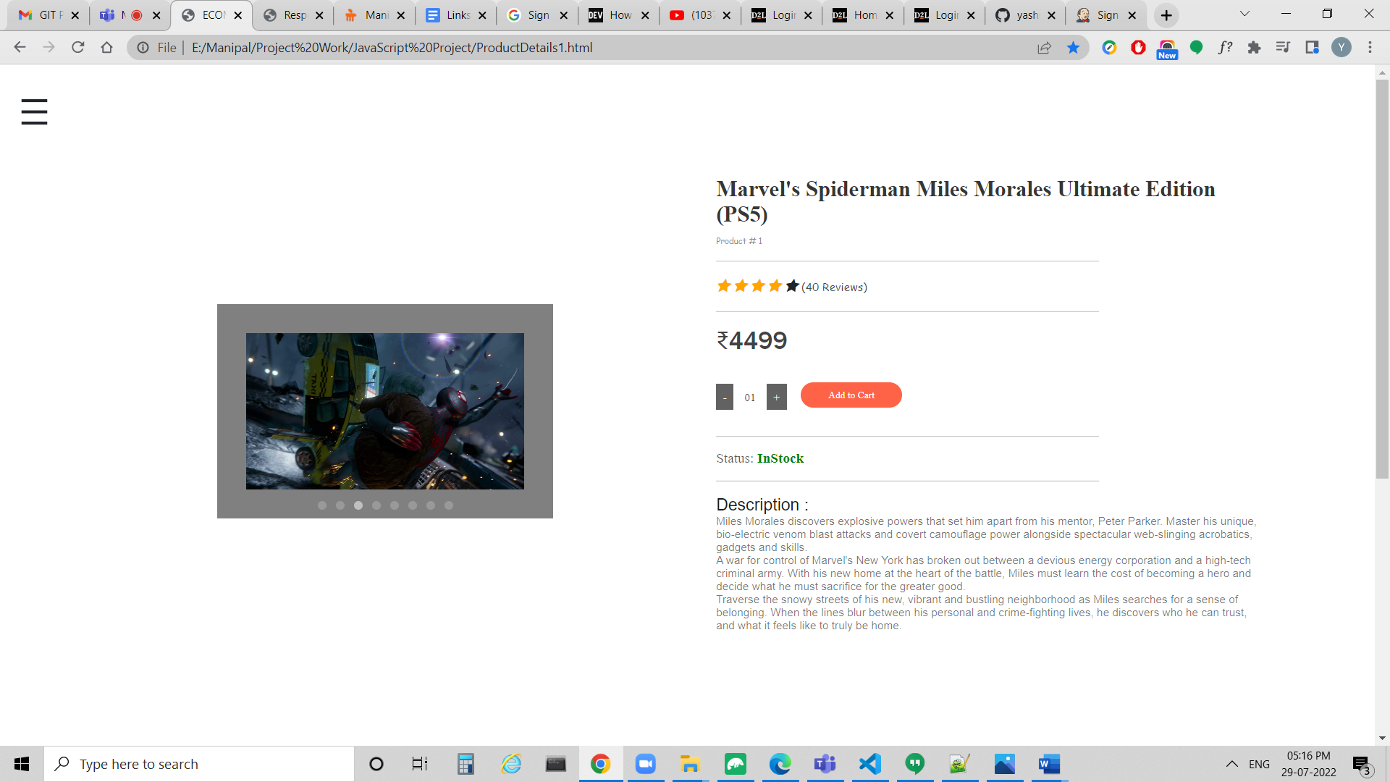

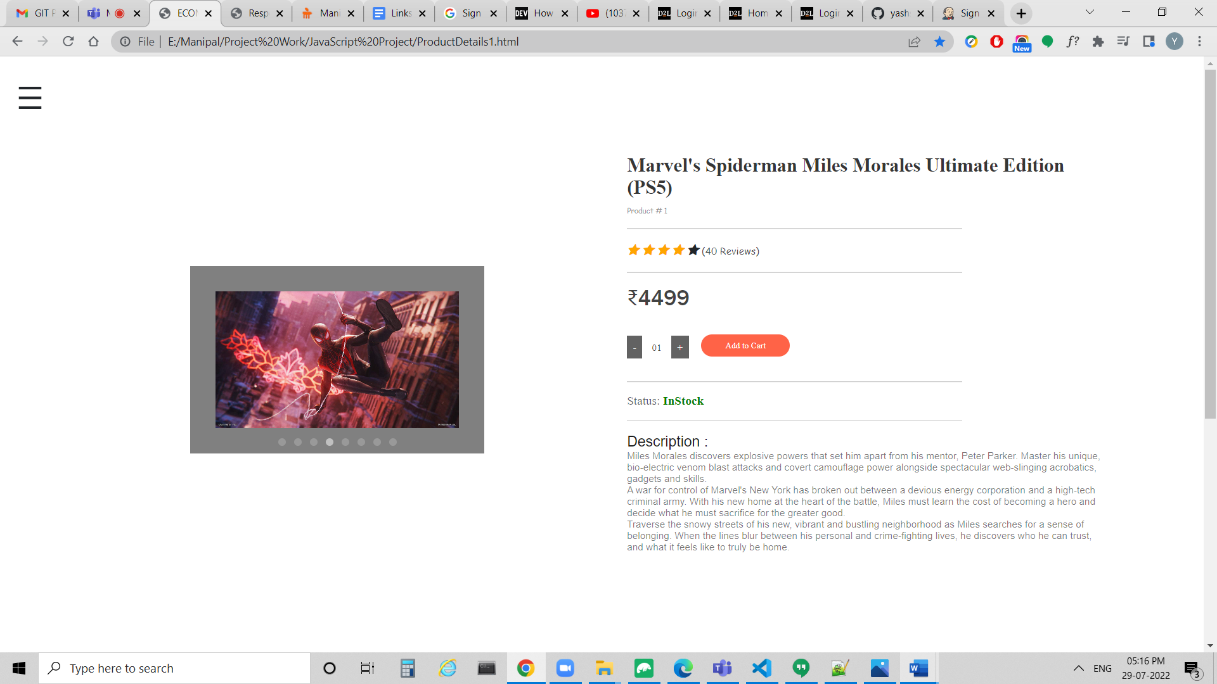

Below is the Screenshot of Apple MacBook Pro(8GB RAM, 256GB SSD, 33.78cm, Space Grey)

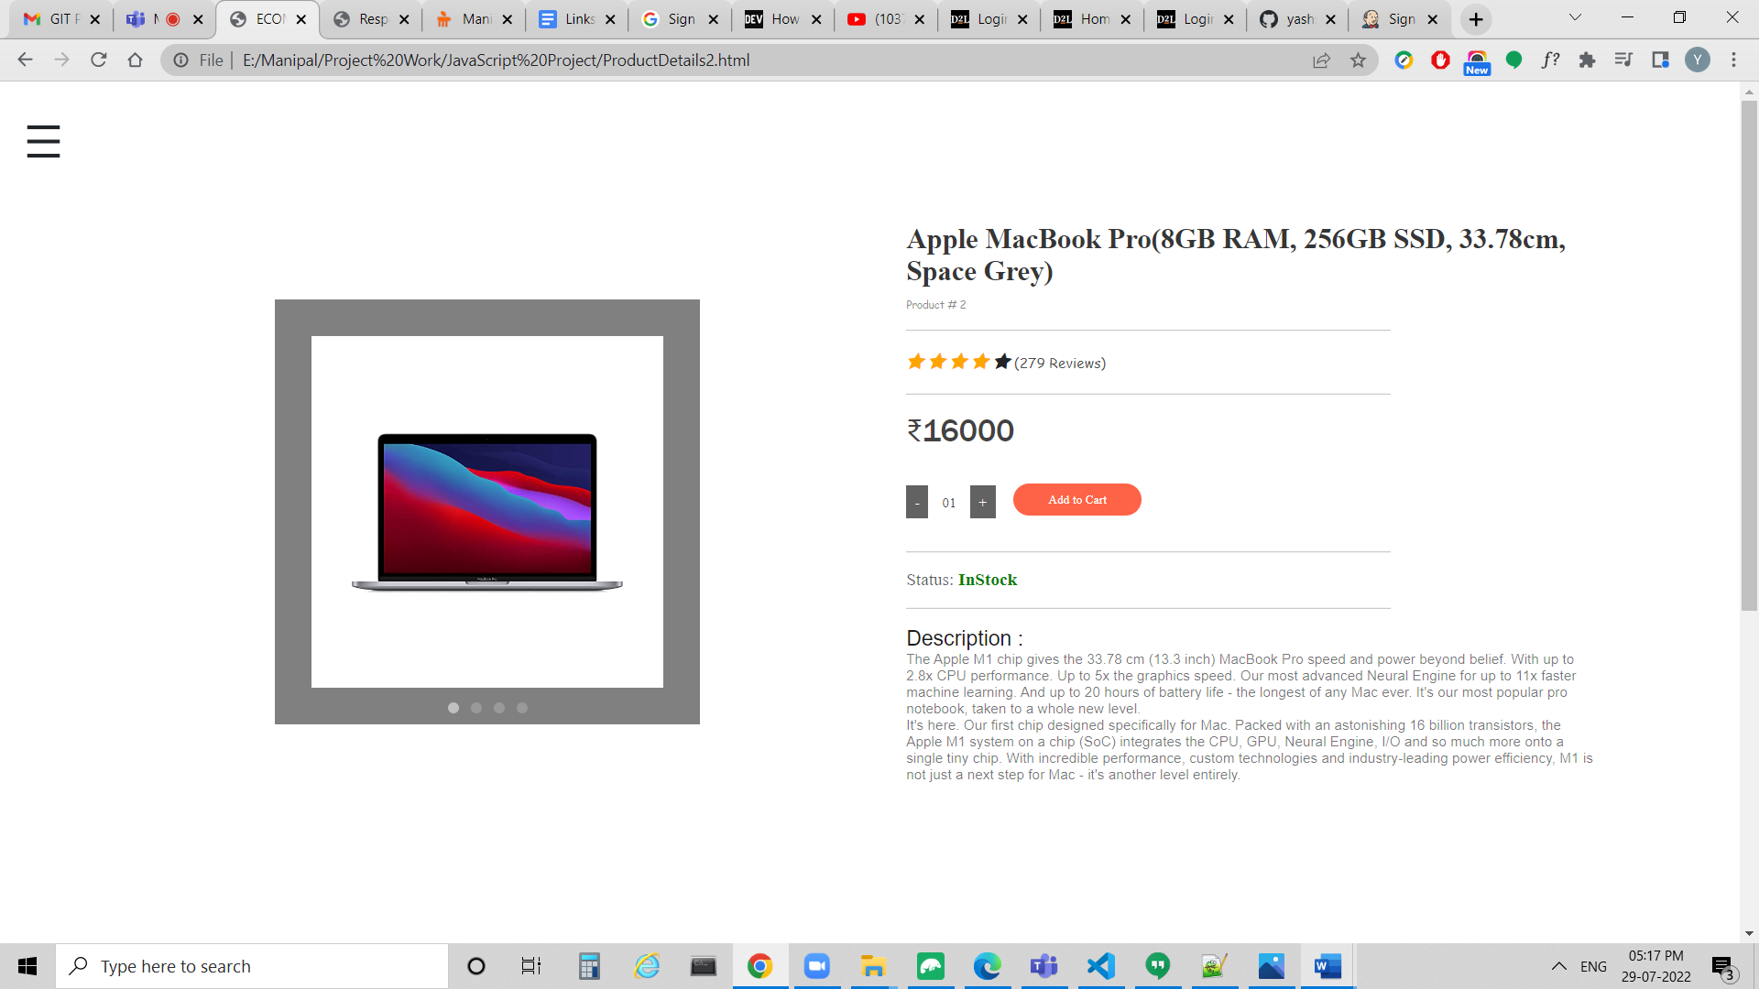

Below is the Screenshot of Trigger Unisex Shoes Puma Black | Everything Black

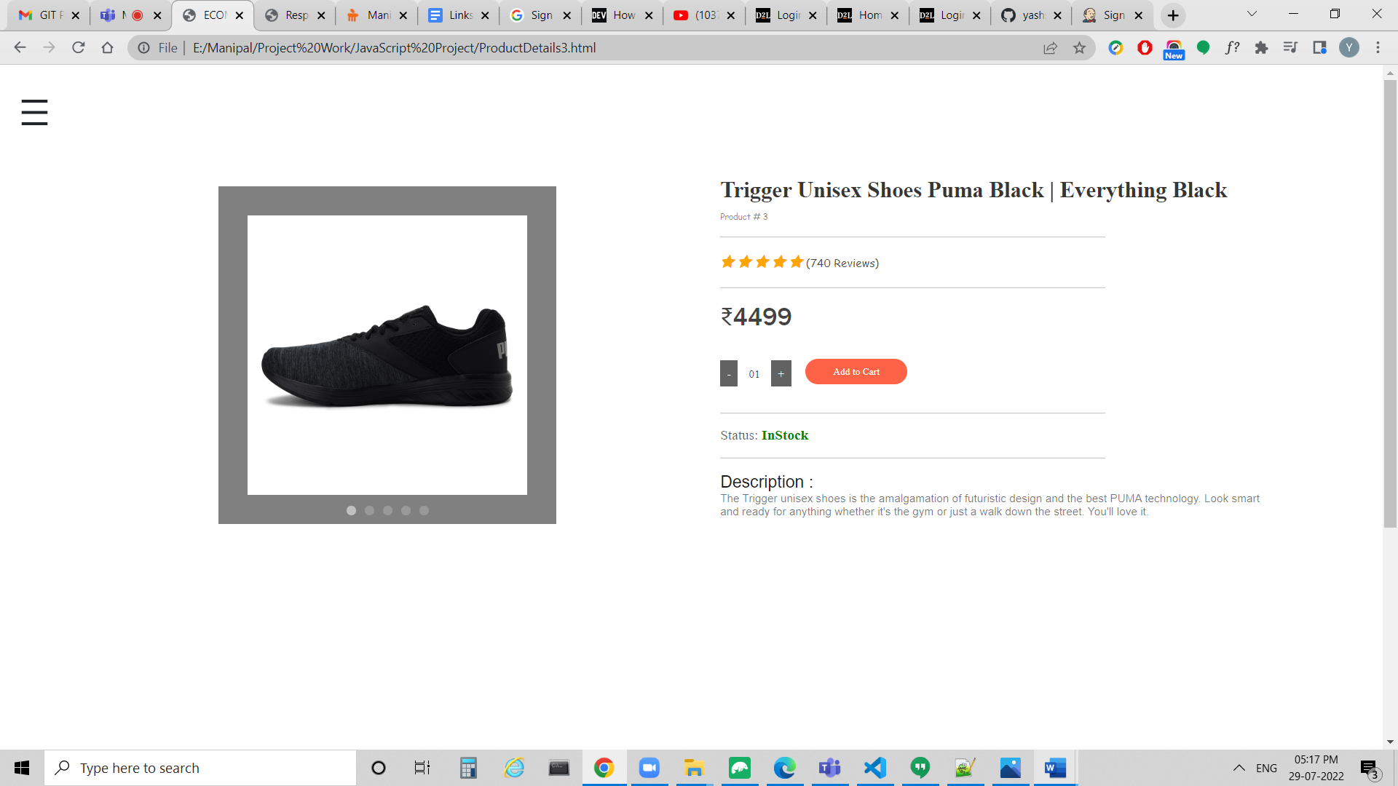

Below is the Screenshot of OnePlus 9 Pro 256 GB, 12 GB RAM, Pine Green, Smartphone

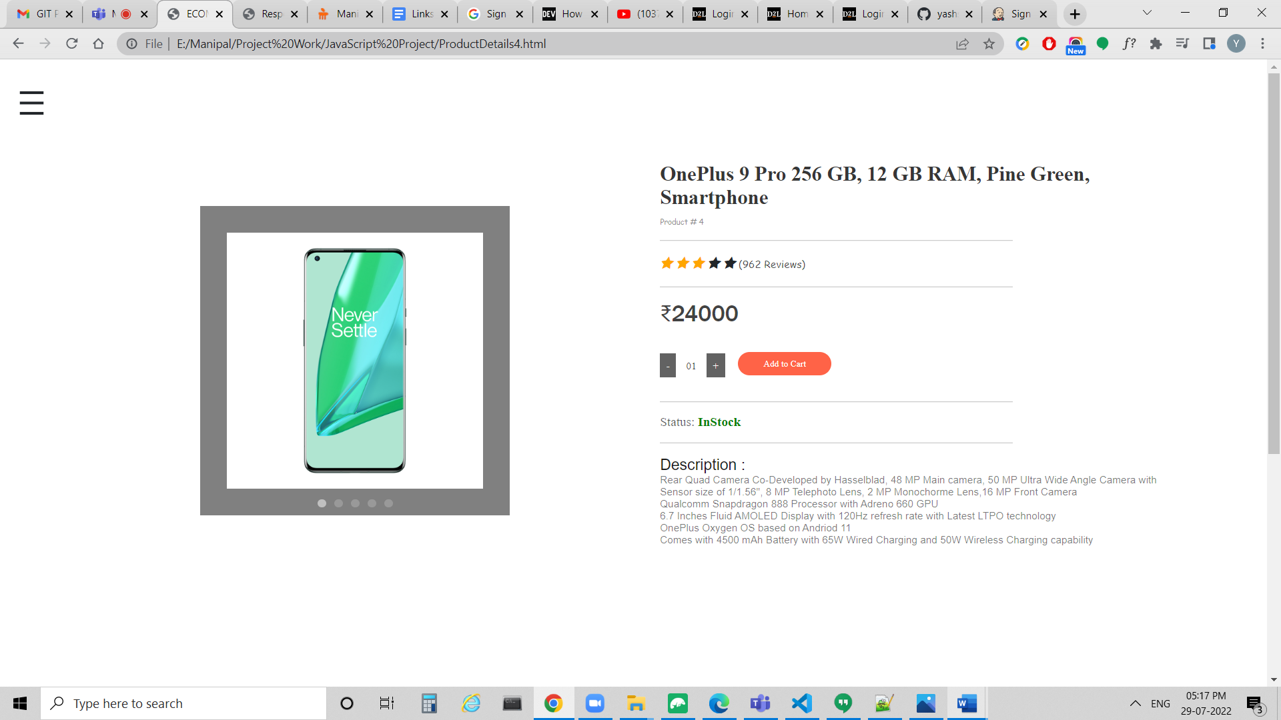

Below is the Screenshot of Van Heusen Beige Jeans For Male

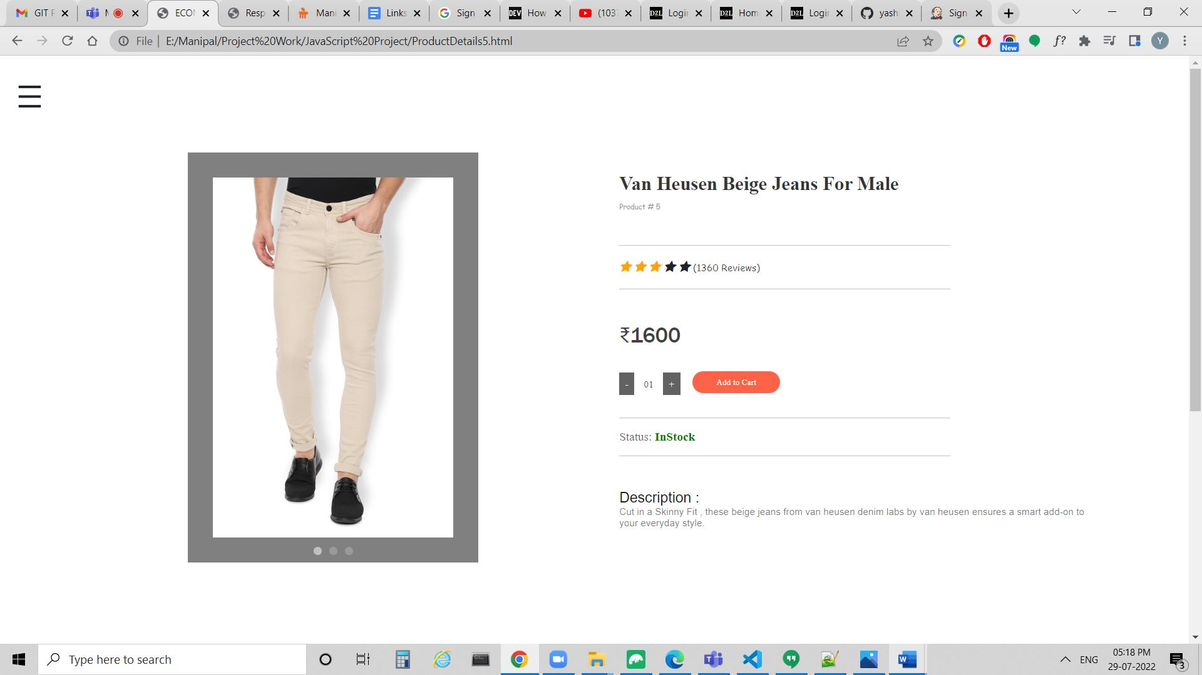

Below is the Screenshot of Van Heusen Yellow T Shirt Men Polo

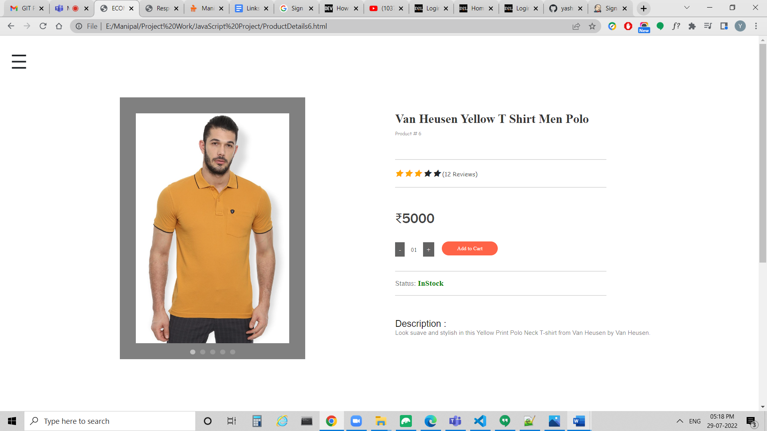

Below is the Screenshot of Black Printed Ready to Wear Lahenga with Blouse | Ye Manly nhi h yaar

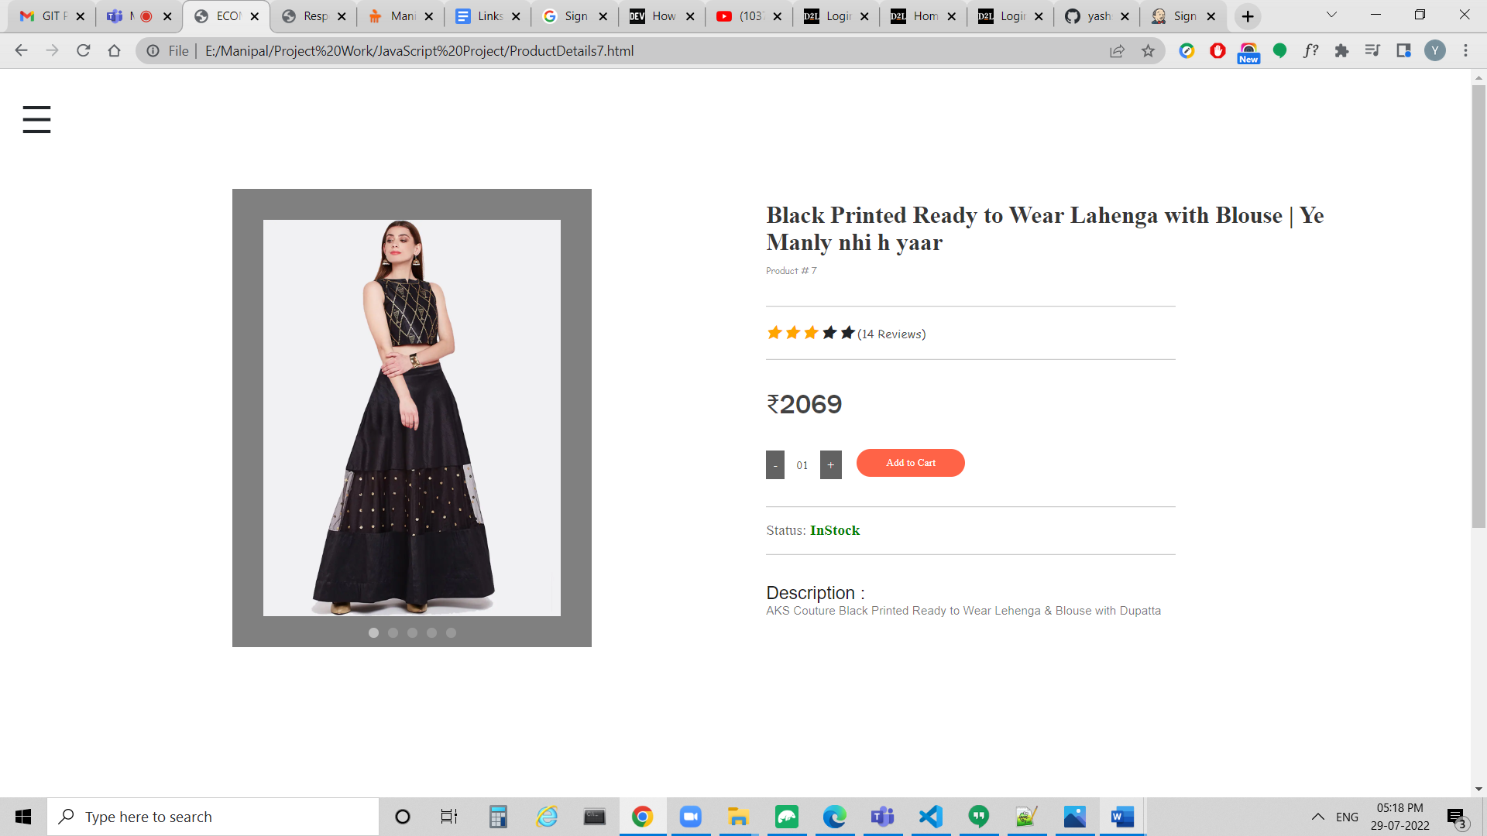

Below is the Screenshot of Canon EOS 5D Mark IV DSLR Camera with 24-105mm f/4L II Lens

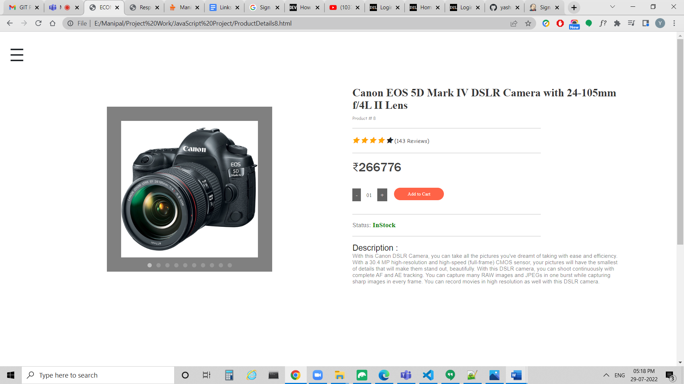

**Contact Page**

In Contact Page, We can click on Contact: [yashsharmaembark@gmail.com](mailto:yashsharmaembark@gmail.com) to send Email. If we hover over Contact: [yashsharmaembark@gmail.com](mailto:yashsharmaembark@gmail.com), We get a Pencil Icon.

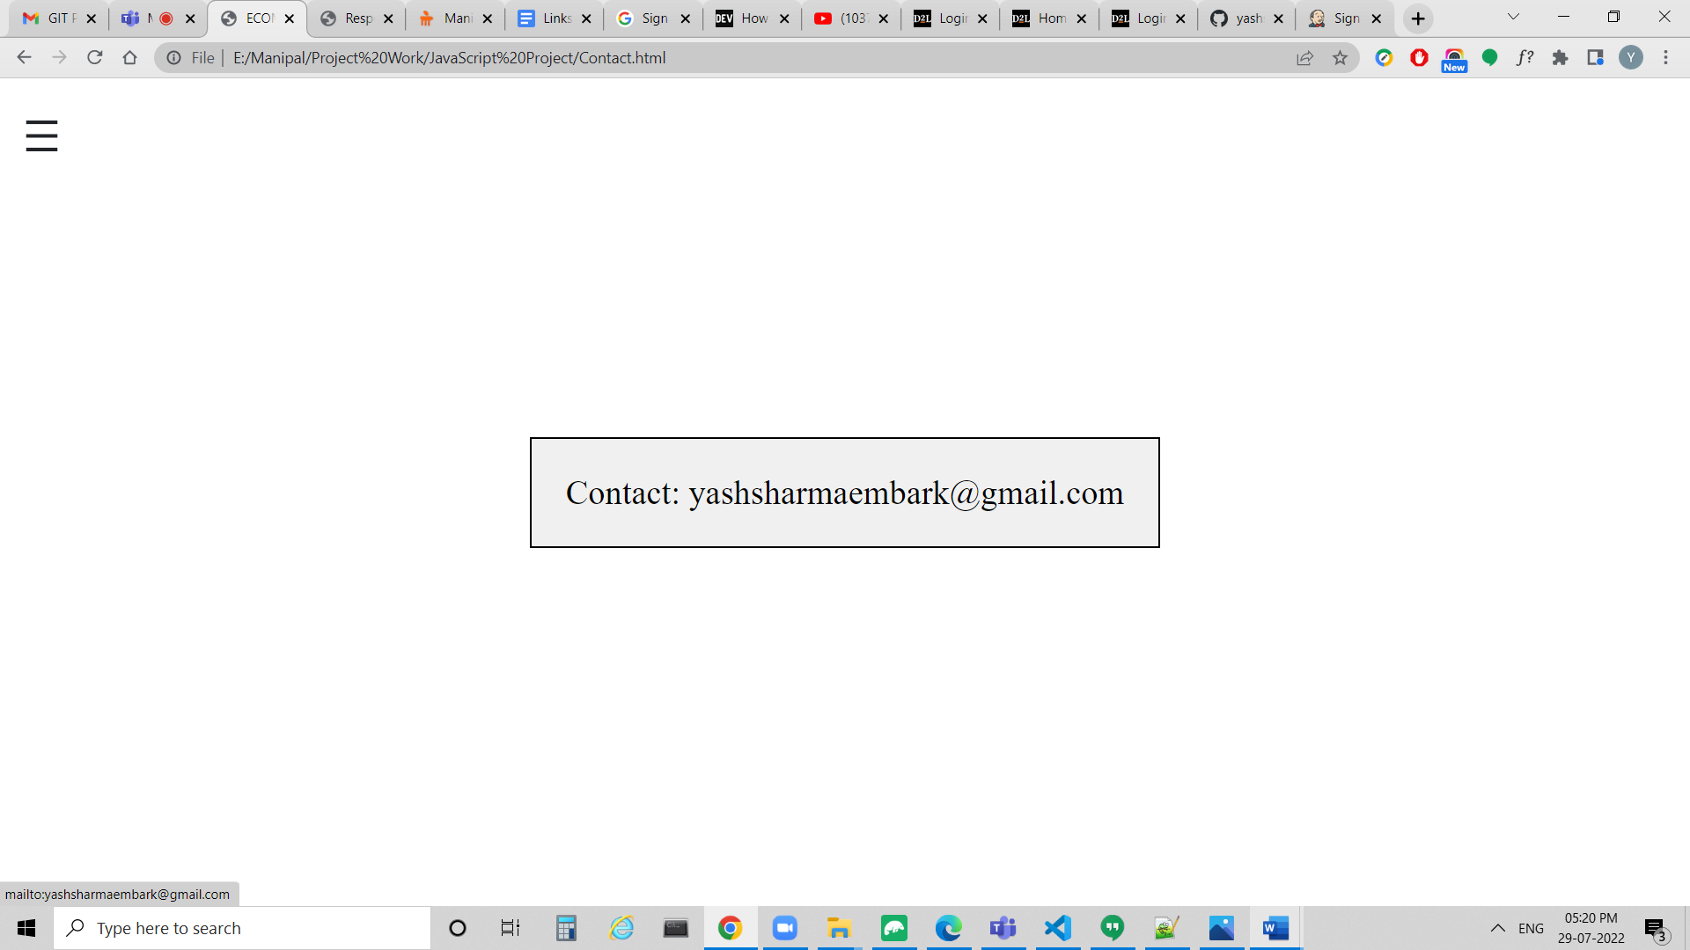

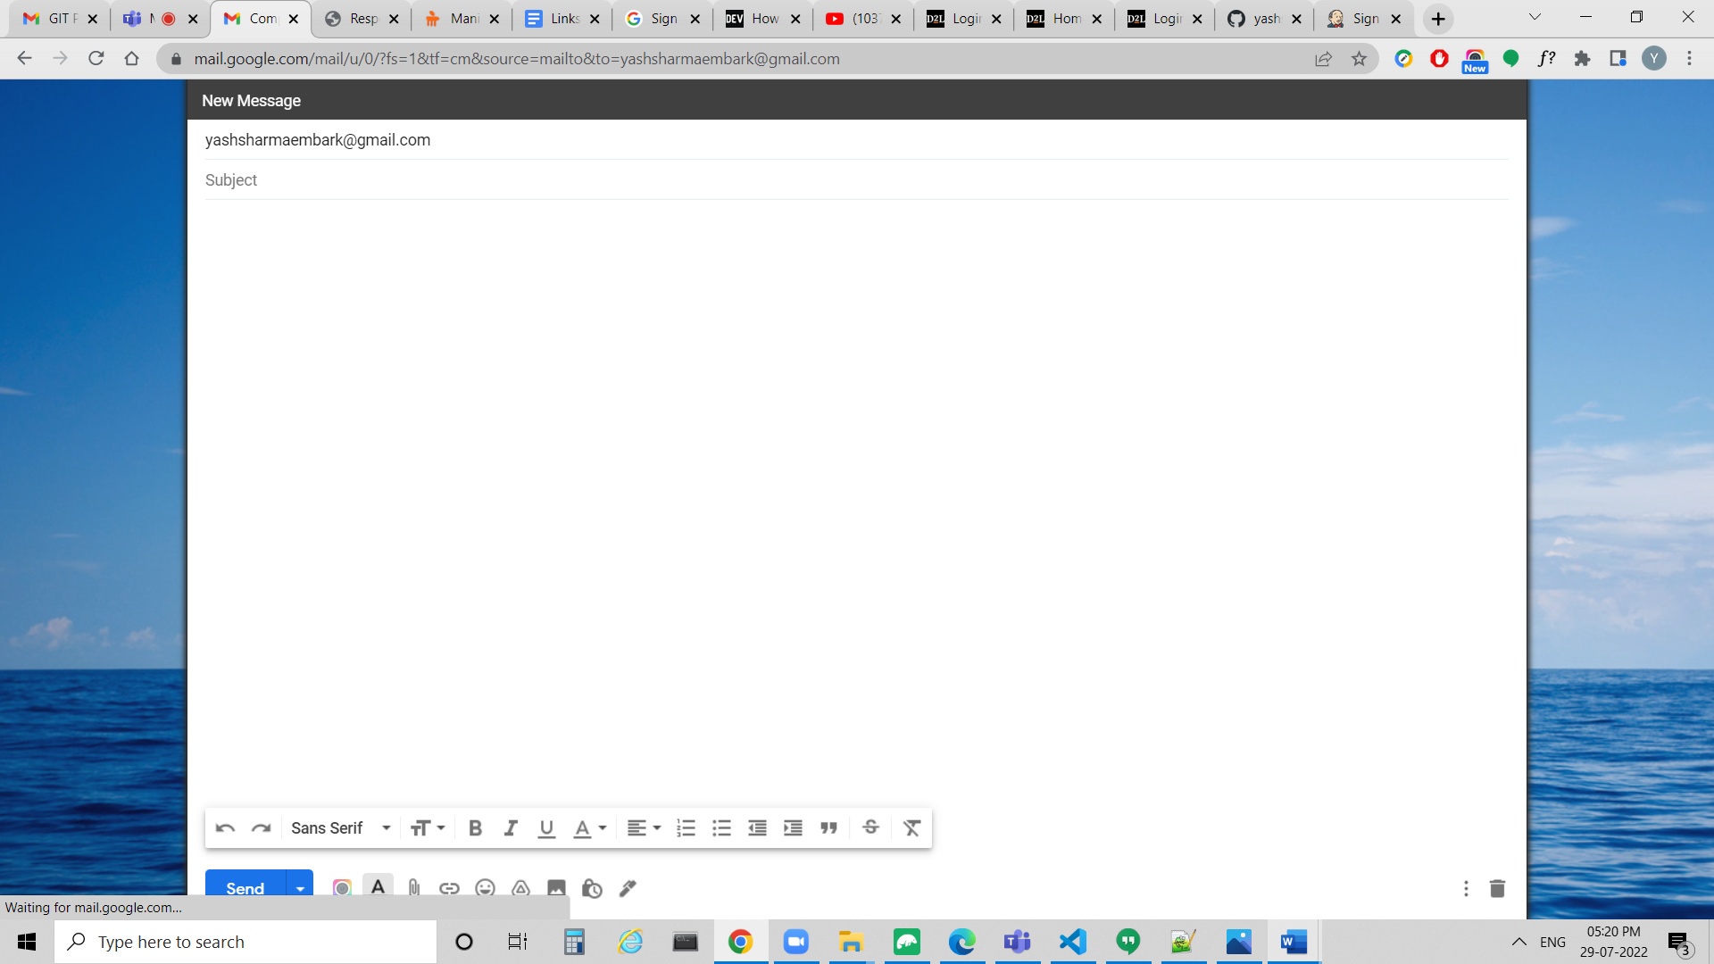

**Conclusion**

In this Website, We have worked on UI and UX using HTML and CSS.

We have added Validations in this Website using JavaScript.

We can go to Contact Page to send Email.

In this Website, We have Overlay Navbar.

In the Home Page, We can find the Banner, Featured Products and Footer.

In Product Details, We can find the description of individual Products.